**MBA in BUSINESS ANALYTICS**

**MANAGEMENT DEPARTMENT_ETERNAL UNIVERSITY**

Management Department of the Eternal University offers admissions in 2 years Internationally Collaborated Programme viz. Masters in Business Administration(MBA) with focus on Business Analytics from the coming academic session 2023-24.

This is an unique twin programme in collaboration with Virginia Commonwealth University, USA and University of North Carolina, Greensboro, USA. Further, the faculty from internationally renowned business schools of USA, Sweden, Portugal, Norway, and the United Kingdom isassociated with the teaching in the programme. On completing the first year at Eternal University, the programme embodies provision of opportunity to students to complete their second year at the Virginia Commonwealth University, USA.



The programme aims to develop competent business executives capable of applying management theory, practices, and techniques to modern businesses. This MBA Programme will create managers who are conscious of their corporate social responsibility and focus on sustainable business practices.





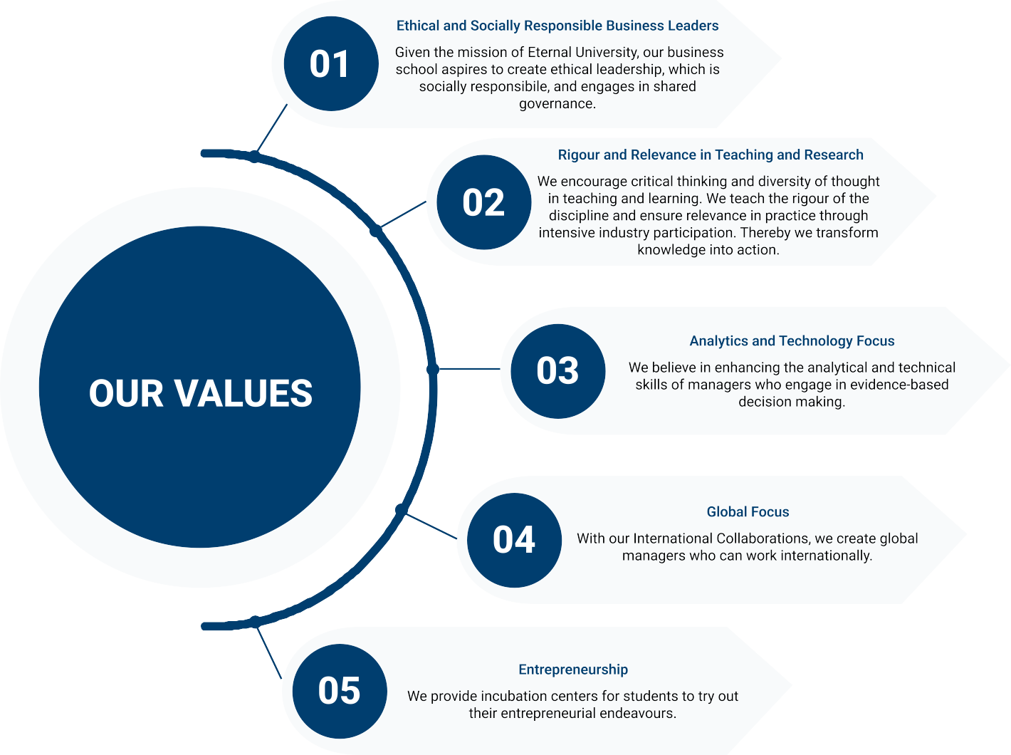



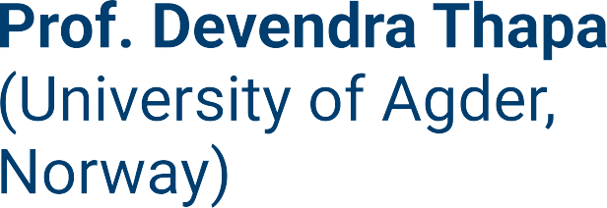

**5. Prof. Tusshar Mahajan**

**(Ph.D.,MBA,M.Tech.,M.Sc.)**